(Please Arrange the header like this and don’t freeze header during scroll)
SUGI INTERNATIONAL PVT. LTD.
Logo

Your Trusted & Reliable Agro Commodity Supply Chain Partner
Tagline
Home About Products Certifications Articales Contact Us
Get a Quote

Automatic Slider Images (We’ll provode images)
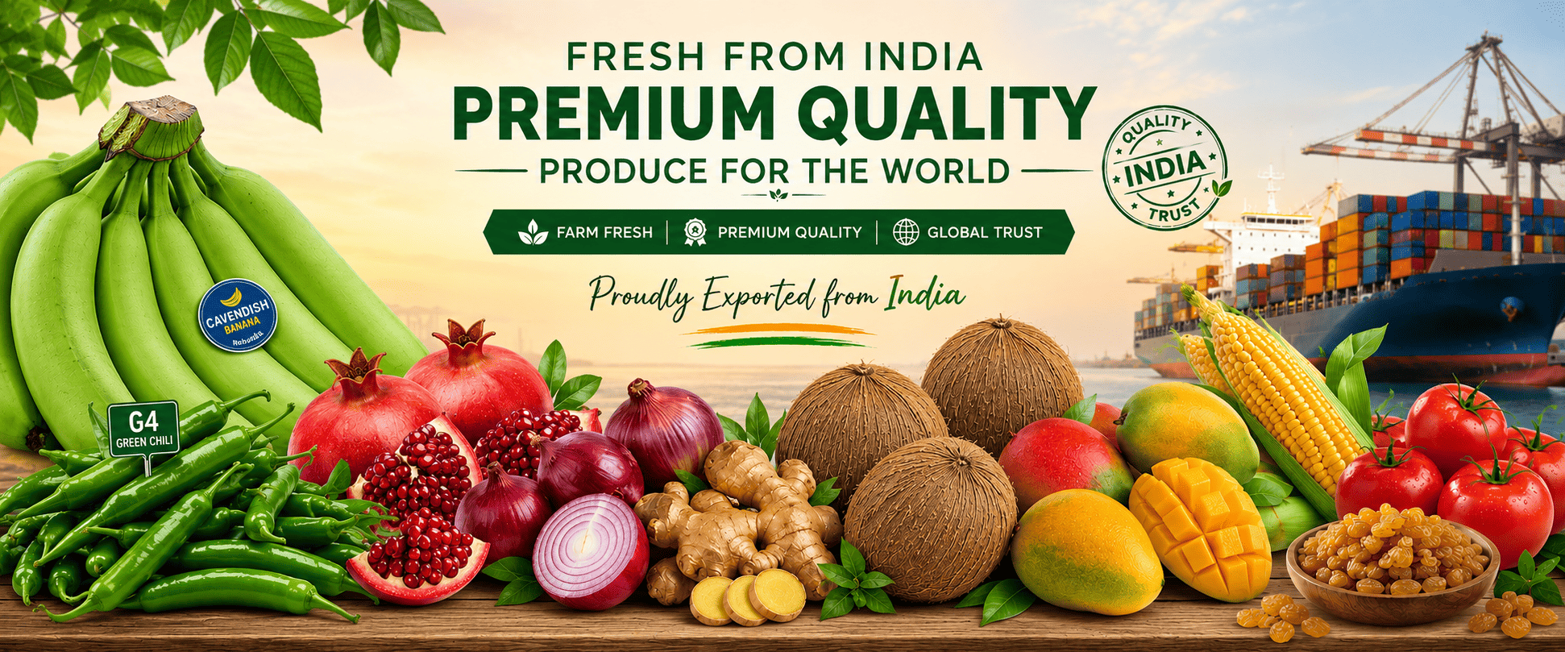
(this image is for you to understand the slider image size)
(Next Section)
Connecting Indian & Globally Sourced Agro Commodities with Global Markets (must be in one line, make it look eyes catching)
Delivering farm-fresh fruits, vegetables, spices, dry fruits and other agricultural products from India to customers worldwide. We provide premium quality produce sourced directly from certified farms with international export standards, competitive pricing, and timely global delivery.
(after texts add 2 redirecting buttons)
- Get a Quote
- Explore Products
(Remove These texts)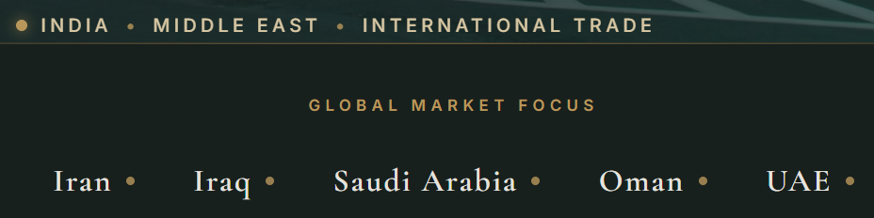
(Next Section)- Replace the current image of about section with provided image of company’s entire operations. And add provided texts at the texts side of this section.
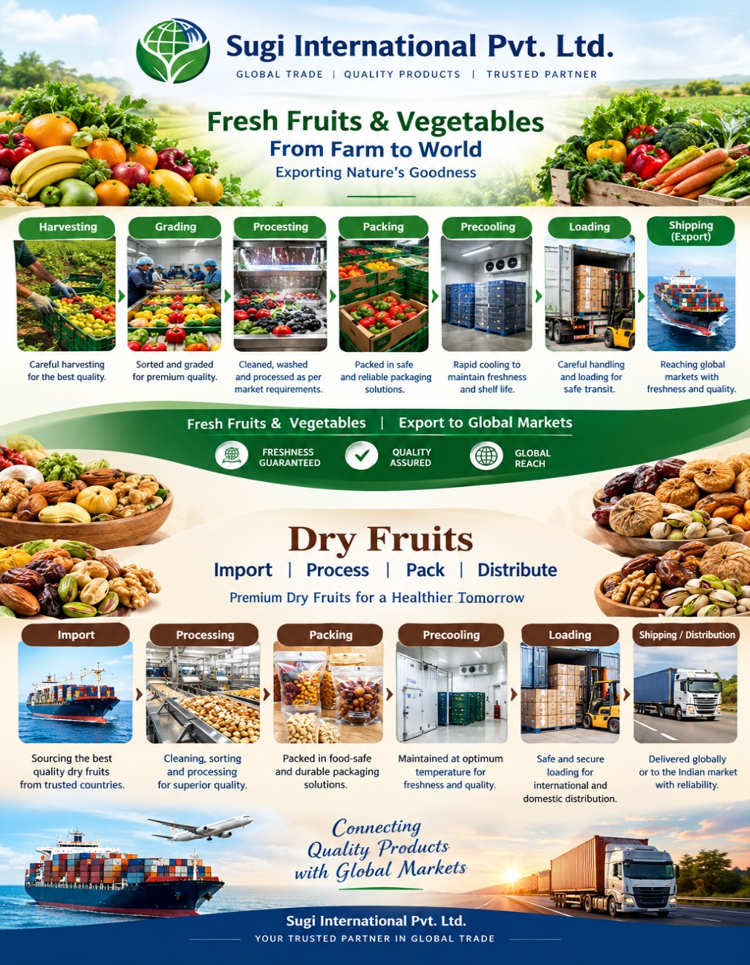

Welcome to Sugi International
Sugi International Pvt. Ltd. is a leading exporter of Indian origin fresh fruits, vegetables, spices, Sweet Corn, Maize, Semi Husked Coconuts & Raisins and other agricultural products from India.
We also Import premium dry fruits from worldwide suppliers and process it in our world class processing units and export in global market.
We specialize in supplying premium-quality products to wholesalers, supermarkets, distributors, retailers, and importers across the world. We distribute our Imported dry fruits in PAN India Market.
With a strong network of experienced farmers, modern packing facilities, and efficient logistics, we ensure every shipment meets international quality and food safety standards. Our commitment to freshness, reliability, and customer satisfaction has made us a trusted export partner in the global agricultural industry.

(Next Section)

Our Products (Indian Origin)- Divide this section into 4 following sub sections:
We export a wide variety of premium Indian origin agricultural products from India, including:
(add 10 manually slidable real Images for each product with ‘Read More’ Button redirecting to the relevant product page-we’ll provide these images)

Fresh Fruits
- Bananas
- Pomegranates
- Mangoes
- Grapes

Fresh Vegetables
- Onions
- Ginger
- Green Chilli
- Tomatoes
- Okra

Indian Spices
- Green Cardamom
- Cloves
- Cinnamon
- Turmeric
- Black Pepper
- Red Chilli

Other Products
- Sweet Corn
- Maize
- Semi Husked Coconut
- Raisins

(Next Section)
Our Products (Imported & Processed in India, Exported Globally & PAN India Distribution)
We Import Dry Fruits and process it in our world class processing units and export to various destinations and distribute in PAN India domestic market as well. Our Imported products are:
(add 10 manually slidable real Images for each product with ‘Read More’ Button redirecting to the relevant product page-we’ll provide these images)
- Cashew (In Shell)
- Cashew (Kernels-whole)
- Almonds (In Shell)
- Almonds (Kernels)
- Pistachios (In Shell)
- Pistachios (Kernels)
- Walnuts (In Shell)
- Walnuts (Kernels)
- Dried Figs
- Dates (Soft/Wet)
- Dry Dates (Kharik/Chuara)
- Saffron
(Next Section)

Why Choose Sugi International? (Dedicate Separate sub section box to each points)
✓ Premium Export Quality Products
✓ Direct Farm Sourcing
✓ International Food Safety Standards
✓ Fresh & Hygienic Packing
✓ Competitive Prices
✓ Fast Worldwide Shipping
✓ Customized Packaging
✓ Export Documentation Support
✓ Timely Delivery
✓ Professional Customer Service
(Next Section)

Export Process (Make it like navigation pointer in one horizontal row)
- Farm Selection
- Harvesting
- Quality Inspection
- Sorting & Grading
- Hygienic Packing
- Cold Storage
- Container Loading
- Worldwide Shipping
(Next Section)

Countries We Export To
Just add a world map which should be pointing these export destinations from india, if you can go little creative and make it animated then it would be better. No need to mention these countries as text.
• UAE
• Saudi Arabia
• Qatar
• Oman
• Kuwait
• Bahrain
• Sri Lanka
• Maldives
• DJibouti
• Ethiopia
• Kenya
• Tanzania
• Mozambique
• Russia
• Japan
• South Korea
• China
• Hong Kong
• Taiwan
• Malaysia
• Singapore
• Thailand
• Vietnam
• Indonesia
• Philippines
• United Kingdom
• Netherlands
• Germany
• France
• Italy
• Poland
• Canada
• United States
• Australia
• New Zealand
and many other international destinations.
(Next Section)

Our Commitment
Our mission is simple—deliver the freshest agricultural products from Indian farms to international markets while maintaining the highest standards of quality, safety, and customer satisfaction.
(Next Section)

Get a Quote (add Button redirecting to quotation request form)
Looking for a reliable fruit and vegetable exporter from India?
Our export experts are ready to assist you with product information, pricing, packaging options, shipping schedules, and documentation.
(Next Section)
Add a automatic slider section to add logos of various certification agencies:
  
(Next Section)
Footer
Navigation Bottons Email Address Social Media redirecting Buttons
Privacy Policy Button Contact Number
Full Address
Interactive Google Map of the Address
@2026 Sugi International Pvt. Ltd. All rights reserved.

